QUESTIONS TO ANSWER
Question 1: Are there any different recycling patterns between counties for each type of waste (organics, WTE, landfilled etc.) based on the waste management by method data? Are the patterns consistent for different types of wastes? 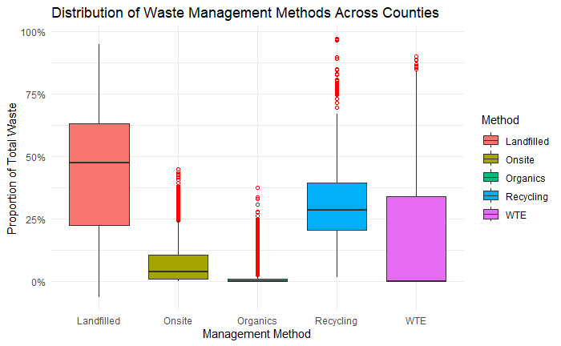

Question 2: Are there any different recycling patterns between counties for each type of recycling category (paper, glass, metal etc.) based on the recycling by category data? Are the patterns consistent for different types of recycling category?

Question 3: What is the average expenditure by category by year, visually and statistically? Is the expenditure by category statistical meaningful? If so, what did you discover?
Question 4: Does the net income (revenue - expenditure) have any impacts on recycling? Is there any
correlation between net income and the amount of total recycling?
Question 5: Perform appropriate visualization to examine patterns in the data related to policy changes
in the history of recycling. Part of the history of policy changes were explained in the data overview
section. Do research on other possible policy changes matching your findings.
Question 6: Do your own research on national recycling data and find the national pattern of recycling
(please do not forget about explaining your dataset and source of it). Is that consistent with Minnesota’s
pattern?

